Seminar of Journal Writing
Skills Workshop # 9

Speaker: Dr. Kupferle, Professor, University of Cincinnati
Date: Monday, June 24, 2019
Time: 9-10 AM
Venue: University of Cincinnati, Baldwin Hall, room 741

Prepared by:
Ramya Ravindrababu, Betsy Layne High School, Stanville, Kentucky
RET Participant for Project #2: Wearable Nanotechnology

This presentation was given by Dr. Kupferle. Dr. Kupferle is an Associate Professor, Department of Chemical and Environmental Engineering, College of Engineering and Applied Science, University of Cincinnati, She teaches graduate and undergraduate courses in chemical and environmental engineering, including material and energy balances, solid and hazardous waste management, and honors classes in sustainable technology. Her primary research expertise is in the treatment of contaminated water and soil. She is particularly interested in chlorination chemistry, water reuse, electrochemistry and biofilms, supervising 12 MS thesis and 3 doctoral students to completion and currently advising 2 PhD and 3 MS students. Prior to joining the tenure track faculty in 2004, she had a long contract research relationship with the U.S. EPA. While Assistant Professor, she received the NSF Early CAREER Award in 2008. She was promoted and tenured in 2011. She was a 2014 Fellow in the prestigious Executive Leadership in Academic Technology and Engineering program at Drexel University (ELATE at Drexel™, and she chairs the Environmental Engineering Program, serves as member of the Advancing Student Success in Engineering and Technology (ASSET) college committee, is a member of the ChEE departmental RPT committee, and advises the UC student chapter of Engineers Without Borders. Dr. Kupferle recently served as co-PI and Project Mentor for a 3-year summer NSF REU Site as well as the most recent 3-yr NSF RET Site. She is also the current PI for the RET Grant.

Dr. Kupferle began the session by reviewing the summer deliverables of RET participants. Participants are responsible for 2 write-ups, a PowerPoint, a project poster, and a video. In the spring semester, after unit implementation, participants will be responsible for an additional poster, video, presentation, and write up. The purpose of this presentation is to guide participants through the process of post-summer deliverables. The session goals include understanding how classroom work can be presented publicly, identify potential presentation venues, and understanding presentation outlines.

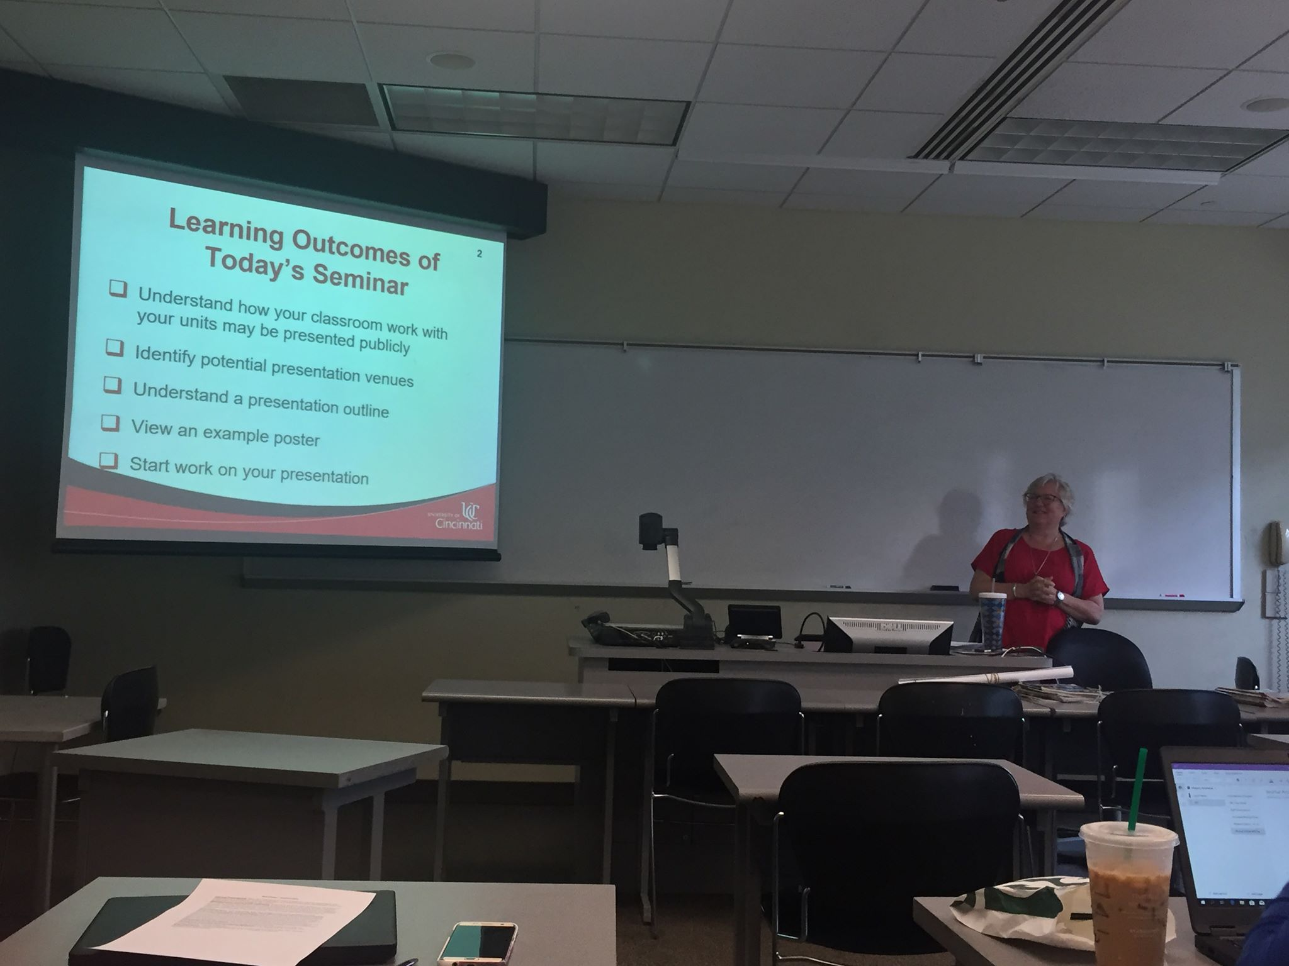 | 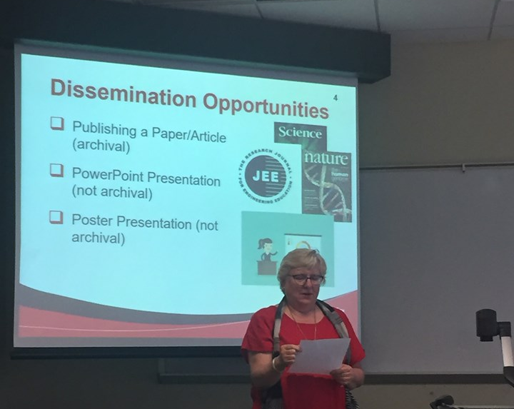
Figure 1: Dr. Kupferle Presenting the Objectives of the Day | Figure 2: Dr. Kupferle introduces different Presentation Opportunities

Dr. Kupferle emphasized the importance of disseminating information this way. The RET experience is important in starting a discussion of how teachers can introduce engineering in their classrooms. By presenting and making participant experiences available, other teachers have the opportunity to join in and contribute to the discussion.

Figure 3: RET Participant, Victoria, Analyzing Articles for Group Activity

Next, Dr. Kupferle distributed different writing samples to each group of RET participants. The participants classified the writing samples as journal articles, technical reports, or magazine articles. She concluded her presentation by discussing the format for presenting unit plans and posters in the spring.

